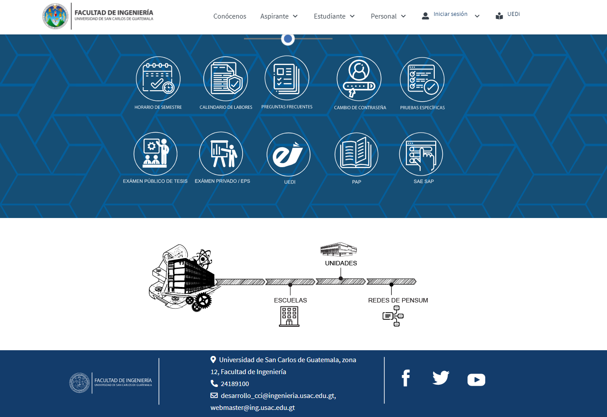

Footer

Main Content

Container

Header